Chapter 10, Solution 22.

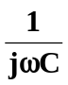
Consider the circuit in the frequency domain as shown below.
R₁
+
-
jwL
+
V_{o}
-

R₂
V_{s}

Let 